Chapter 3, Problem 92

Using Fig. 3.28, design a problem to help other students better understand transistors. Make sure you use reasonable numbers!
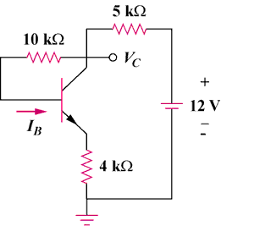
R₁
R₂
+
V₁
–
R₃

Figure 3.128
For Prob. 3.92.

